

Lab 5

CS 5-1 - BSCS – Operating System Lab

Name: Sharaiz Ahmed SAP: 57288

1. creat()
This program demonstrates the use of the creat() system call to make a new file in Linux.
It shows how file descriptors are assigned when a file is created.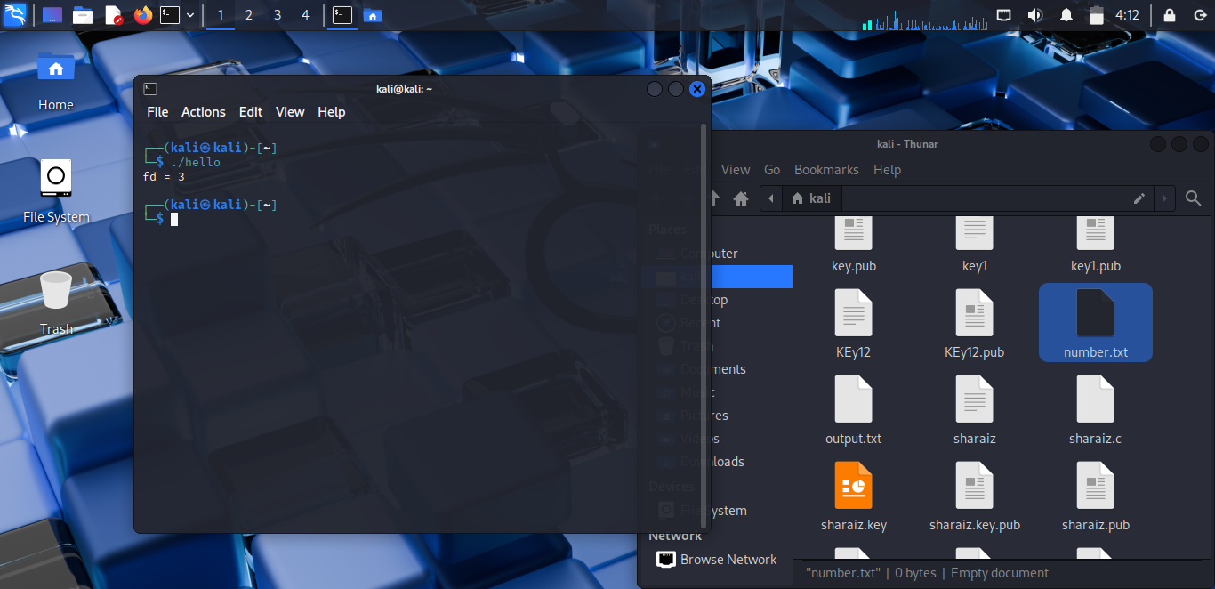
2. open()
This program opens a file for reading and writing using the open() system call.
It shows how to use flags like O_CREAT, O_RDWR, and O_TRUNC.
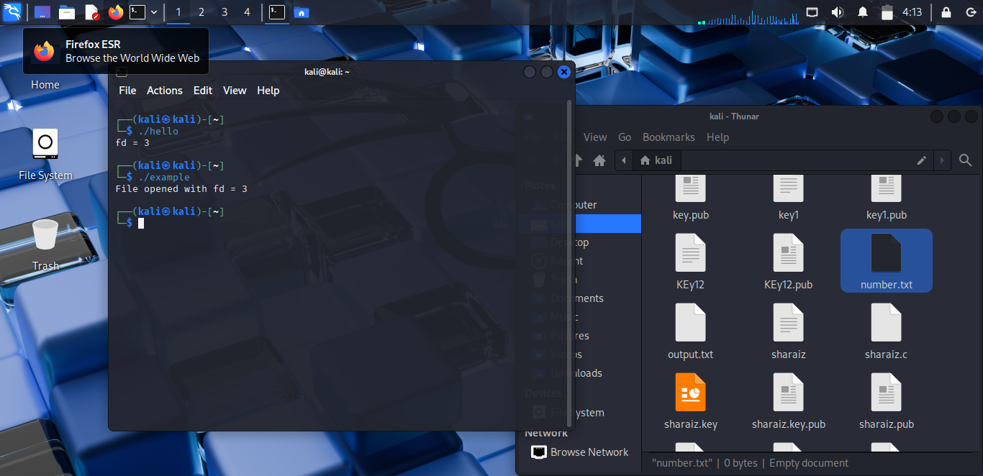
3. close()
This program demonstrates closing a file descriptor using the close() system call.
It ensures resources are freed and the file is no longer accessible via that descriptor.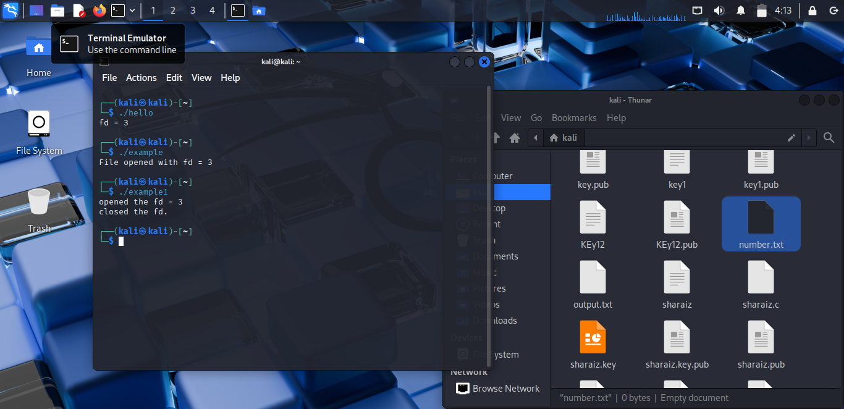
4. read()
This program reads data from an existing file using the read() system call.
It shows how file contents are copied into a buffer in memory.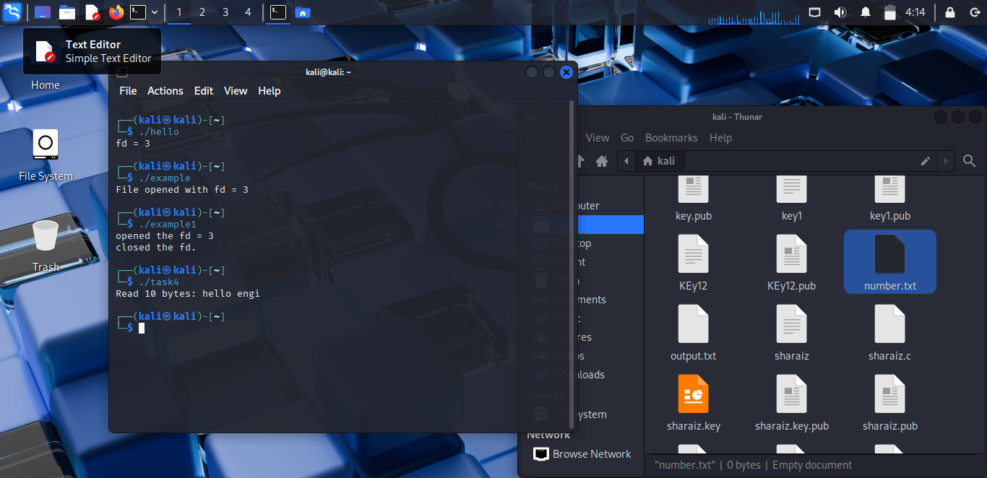
5. write()
This program writes data into a file using the write() system call.
It demonstrates how data from memory is saved into disk storage.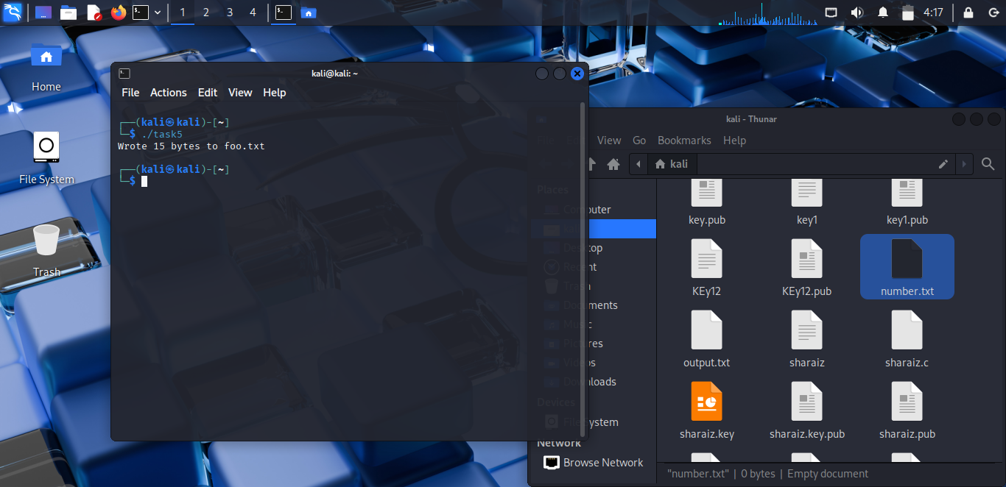
6. hello world using system calls
This program prints “hello world” without using printf, only system calls.
It demonstrates low-level file and terminal I/O in Linux.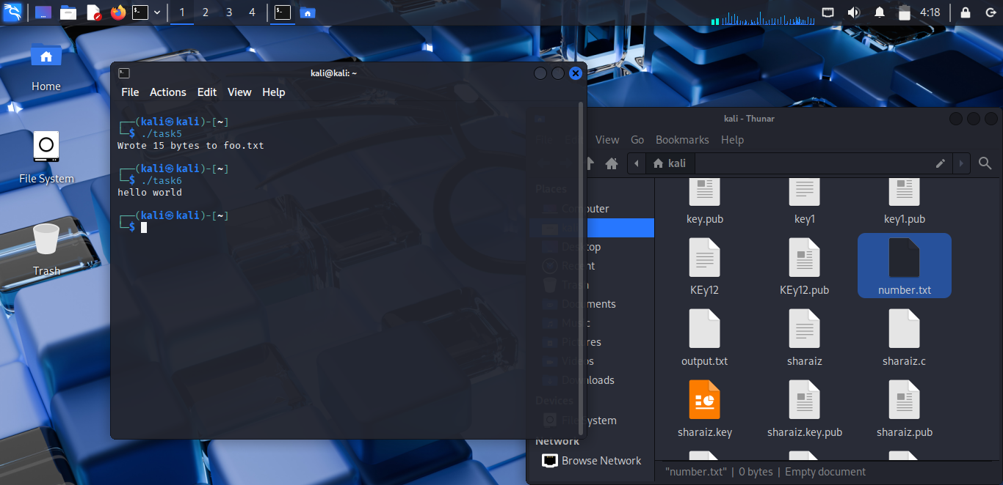
7. lseek()
This program uses lseek() to move the file pointer to a specific location.
It allows reading/writing from different positions inside the same file.
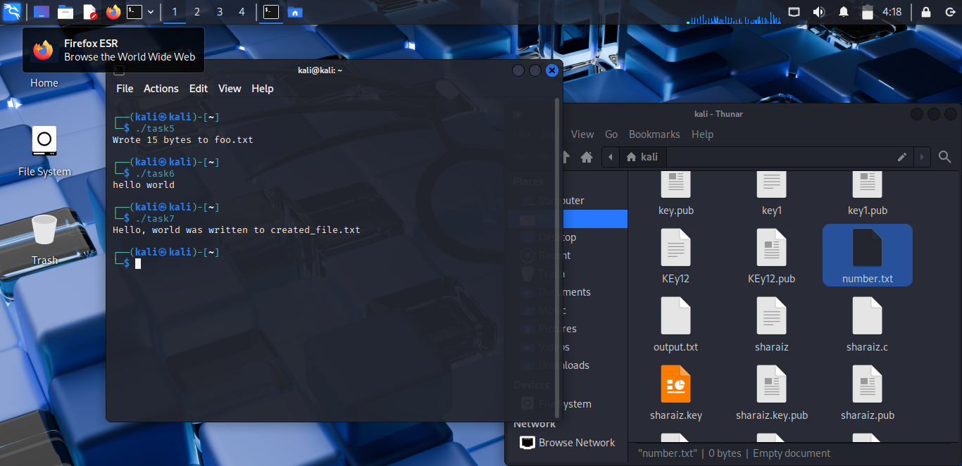

8. Lab Task (Factorial)
This program opens a file for reading and writing, reads a number from it, and calculates its factorial.
The result is appended back into the same file in the format “Factorial is: number”.